**PROJECT 1- iRobot’s DATA MANUAL**

**CURRENT VISION DIAGRAM**

DATA CAPTURE

(INPUT)

DATA DESTINATION

(OUTPUT)

DATA INGESTION

(PROCESS)





Europe Reports/Analytics

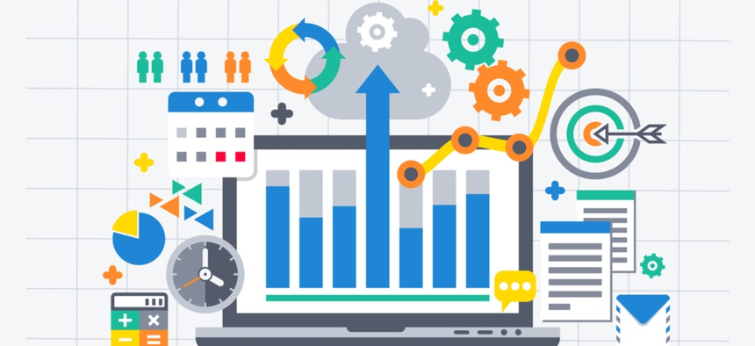

USA

Europe

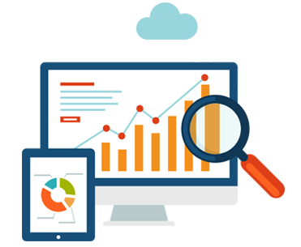

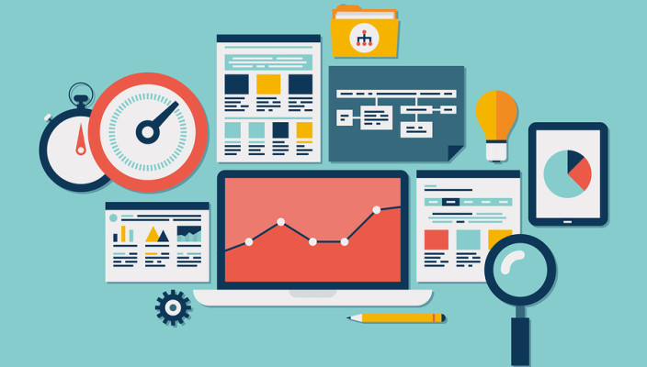

Asia Master DB

Algorithms

Analytics

USA Master DB

Asia

USA Reports/ Analytics

Data from the databases



Europe Master DB

Asia Reports/ Analytics

Internal data of all employees



No data synchronization is done across all the offices, leading to redundancy and inconsistency



Because there is no consolidation, the reports are not generated in a standard template



USA

Asia

Europe

Robot/Firewall/Vendor Data

Better resource allocation

**PROJECT 1- iRobot’s DATA MANUAL**

**FUTURE VISION DIAGRAM**

DATA CAPTURE

(INPUT)

DATA DESTINATION

(OUTPUT)

DATA INGESTION

(PROCESS)





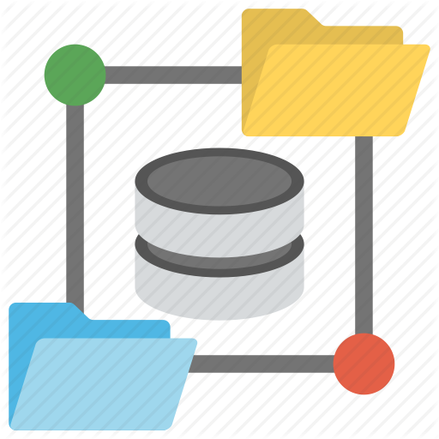

USA

Europe

Algorithms

Analytics

Asia



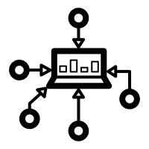

Data from all databases



An integrated and standardized data distribution center

Internal Data of employees

A standard template for reports across all offices



Consolidated data store

Master DB

Data Integration

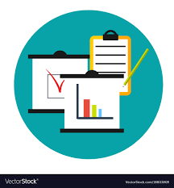





Europe

USA

Asia

Robot/Firewalls/Vendor Data

**PROJECT 2- ANALYTICS USING VIRTUAL WALL DATA**

**CURRENT VISION DIAGRAM**

DATA CAPTURE

(INPUT)

DATA DESTINATION

(OUTPUT)

DATA INGESTION

(PROCESS)







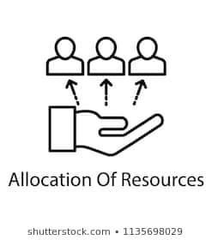

Because the data is left unused, no reports or analysis is generated on it.

Company invests and allocates resources for providing virtual wall free with a robot

The data generated by the wall is collected on the cloud via IOT





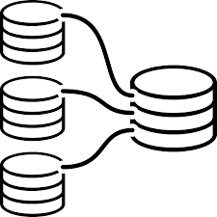



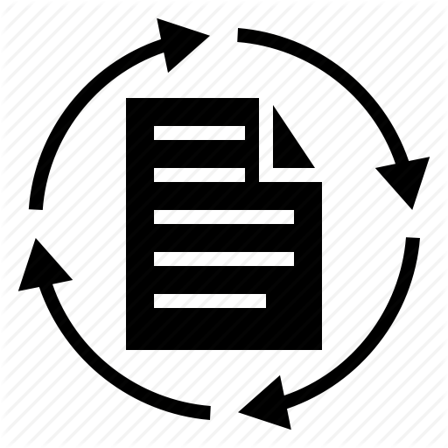

The data is left unfiltered and unprocessed resulting in inconsistencies and data loss with creation of data silos

Data is generated from the virtual wall, once it is used with the robot.

Data is collected in huge amounts, but is neither processed nor filtered

**PROJECT2- ANALYTICS USING VIRTUAL WALL DATA**

**FUTURE VISION DIAGRAM**

DATA CAPTURE

(INPUT)

DATA DESTINATION

(OUTPUT)

DATA INGESTION

(PROCESS)



Standardized reports & analytics generated



The data generated by the wall is collected on the cloud via IOT



Data processing

Company invests and allocates resources for providing virtual wall free with a robot

Data Integration

Leading To

















Better resource allocation

Better financial investments

Thus, no data silos are generated and there is no data loss or redundancy.

Data is generated from the virtual wall, once it is used with the robot.

Analytics

Algorithm